Power-Up Pita Pizza Recipe
By Kristine Caiafa, RD
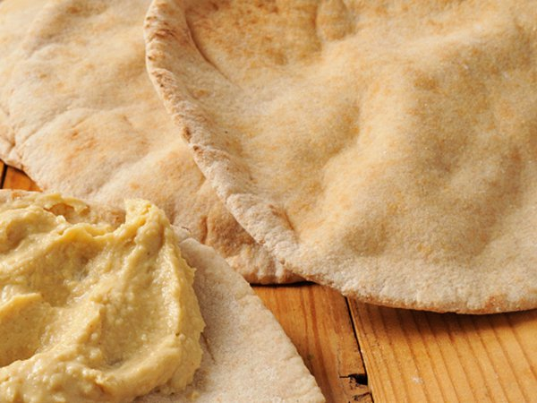
Kids will love this mix of Mediterranean flavors and the fun of pizza. And it will be ready in no time for an after-school snack, lunch or a light dinner.

Ingredients
2 whole-wheat pitas (6-inch diameter)
¼ cup hummus
½ cup fresh or frozen spinach, chopped (if frozen, defrost and drain first)
½ cup black beans, rinsed
½ cup artichoke hearts
¼ cup non- or low-fat Swiss cheese, shredded

Directions
Preheat over to 325ºF.
Spread hummus evenly over pitas. Add beans, spinach and artichoke hearts. Top with cheese.
Bake in the oven for 15 minutes or until pita is toasted. Let cool and enjoy.

Nutrition Information
Serving size: ½ pita
Serves 4
Calories: 160; Total Fat: 2g; Saturated Fat: 0g; Total Carbohydrate: 29g; Fiber: 7g; Protein 8g

http://www.eatright.org/resource/food/planning-and-prep/recipes/power-up-pita-pizza-recipe

Chocolate Chip and Oatmeal Chewy Bars Recipe
By Kristina LaRue, RD, CSSD, LDN, CLT
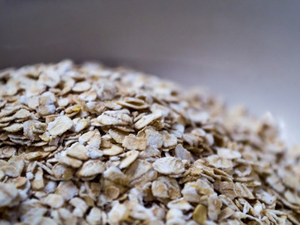
RightOne/iStock/Thinkstock
These are the ultimate homemade snack — soft like an oatmeal cookie and made with wholesome ingredients you can feel good about.

Ingredients
½ cup natural or regular peanut butter
1 extra ripe banana, pureed
¼ cup clover honey
2 tablespoons water
¼ teaspoon coarse crystal salt
2 cups quick-cooking rolled oats
⅓ cup raisins
⅓ cup semi-sweet mini chocolate chips

Directions
Preheat oven to 325°F. Line an 8-by-8-inch baking dish with parchment paper.
Whisk together peanut butter, banana, honey, water and salt. Stir in oats, raisins and chocolate chips. Pour mixture into baking dish. Mash down firmly to form to pan and smooth top with back of a spoon.
Bake for 25 minutes. Place bars in freezer for 15 minutes to cool quickly and slice into 16 individual bars. To keep fresh, store in airtight container in refrigerator for up to seven days.

Nutrition Information
Serving size: 1 bar (35 grams)
Serves 16
Calories: 135; Total fat: 6g; Saturated fat: 2g; Cholesterol: 0mg; Sodium: 66mg; Carbohydrates: 20g; Fiber: 2g; Sugars: 10g; Protein: 3g; Potassium: 148mg; Phosphorus: 83mg
http://www.eatright.org/resource/food/planning-and-prep/recipes/chocolate-chip-and-oatmeal-chewy-bars-recipe

Yogurt on the Go

Note: This recipe is especially for teens who must avoid gluten, a type of protein found in many foods.
This quick and easy-to-make dish is a great source of calcium and will help you jump-start your morning!
Prep time: 5 minutes

Ingredients:
¾ cup light fruit-flavored yogurt
1 tablespoon raisins
1 tablespoon sunflower seeds
1/3 cup strawberries

Directions:
Mix all ingredients in a plastic cup.

Serves: 1

Serving size: about 1¼ cup

Nutritional analysis (per serving):
232 calories
7 g protein
4 g fat
0 g sat. fat
40 g carbohydrate
3 g fiber
3 mg cholesterol
88 mg sodium
222 mg calcium
0.9 mg iron
Note: Nutritional analysis may vary depending on ingredient brands used.

Variations and suggestions:
For a variety, use different flavored yogurt, fruit, and nuts.

https://kidshealth.org/en/teens/cd-yogurt-go.html?WT.ac=t-ra#catrecipes

Guacamole
Recipe courtesy of Friday Arts’ Art of Food
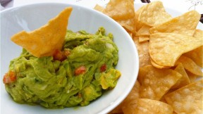
Recipe courtesy of AUNI, the Agaston Urban Nutrition Initiative
When Michele Obama challenged American schools to create healthy cafeteria recipes this is one of them.
- 1 lime –juiced
- 1 teaspoon salt
- 1/2 cup onion – diced
- 3 tablespoons fresh cilantro - chopped
- 2 plum tomatoes - diced
- 1 teaspoon garlic - minced
- 1 pinch ground cayenne pepper (optional)
- 1 pinch cumin (optional)

Directions
- In a medium bowl, mash together the avocados, lime juice, and salt.
- Mix in onion, cilantro, tomatoes, and garlic. Stir in optional spices.
- Refrigerate 1 hour for best flavor, or serve immediately.

Rock Your Guac
(on something other than chips!)
- on a burger instead of ketchup, mustard and mayo
- piled on a baked potato instead of sour cream and cheese
- as dressing over your salad
- on a sizzling steak sandwich
- spoon guacamole instead of cheese and sour cream on black bean or tortilla soup or chili
- dip your veggies into guacamole

Baked Oatmeal Recipe
By Alexandra Caspero, MA, RD

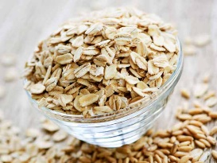
Elena Elisseeva/iStock/Thinkstock
This perfect make-ahead breakfast is great on its own or served like cereal. My favorite way to enjoy baked oatmeal is topped with a splash of cold milk, a sprinkle of brown sugar and fresh berries.

Ingredients
1½ cups quick cooking oats
¼ cup packed brown sugar
½ teaspoon ground cinnamon
1 teaspoon baking powder
¼ teaspoon salt
1 egg
½ cup plus 1 tablespoon milk
⅓ cup maple syrup
1 tablespoon melted butter

Directions
- Preheat the oven to 350°F.
- In a large bowl, mix together the quick cooking oats, brown sugar, cinnamon, baking powder and salt. Mix until well combined and set aside.
- In a separate bowl, beat the egg. Whisk in milk, maple syrup and melted butter. Pour the wet ingredients into the oat bowl and stir to combine.
- Lightly spray an 8-by-8-inch glass baking dish (or comparable dish) with cooking spray and pour the oatmeal mixture in.
- Bake for 30 minutes until set and golden brown.
- Enjoy as is or serve with more milk, brown sugar, fruit and chopped nuts.

Cooking Note
For those with allergy concerns, this recipe can be made egg-free and dairy-free. Substitute almond milk for dairy milk. Instead of egg, substitute: 2 tablespoons ground flaxseed meal combined with 4 tablespoons water until a gel forms. Add half of a mashed banana for extra moisture. Add in the flaxseed mixture and ½ mashed banana with the liquids, mix and bake as directed.

Nutrition Information
Serving size: ½ cup
Serves 6
Calories: 194; Total fat: 4g; Saturated fat: 2g; Cholesterol: 37mg; Sodium: 206mg; Carbohydrates: 36g; Fiber: 2g; Sugars: 22g; Protein: 5g; Potassium: 169mg; Phosphorus: 148mg

